RMET Project Report

**Reliability of DEBE Feedback**

For checking the reliability of DEBE feedback and finding the **breakdown point** (number of samples at which sample data does not match very well with actual data), we have done both a qualitative as well as quantitative analysis of the given datasets.

In order to understand how well a curve derived from a ‘n’ samples matches the curve derived from all samples combined we calculated the SSE (Sum of Squares of Error) for each sample.

**Methods**

**Quantitative Analysis**

The algorithm followed is explained as follows:

N = Total number of students

1. FOR n = N to 10
   1. FOR I = 1 to 100
      1. Randomly select ‘n’ student sheets (without replacement)
      2. Consolidate all the readings from the ‘n’ selected student sheets
      3. Apply moving window average (window size = 2) on the consolidated data frame
      4. Calculate “Net Engagement” and “Net Difficulty” (in form of percentage)
      5. Calculate the SSE for each data frame (comparing the curve with n=N)
   2. Plot envelope curve for each ‘n’
   3. n = n - 4
2. Plot box plot for each ‘n’ to compare the results side-by-side.

**Qualitative Analysis**

For each ‘n’ (number of samples), we run 100 iterations. All the 100 curves hence obtained are plotted on the same graph in order to obtain an **envelope** which is then visually compared with the ideal **Net Engagement** and **Net Difficulty** curves to see if the peaks and troughs are similar.

**Dataset 1 (Segmentation and Paging Analysis)**

For the first data set, there were total 69 students’ feedback data made available. We downsampled the feedback data from n=69 to n=15, reducing n at intervals of 5

For the first data set, the net engagement and net difficulty curves (at n = 69) look like the following:

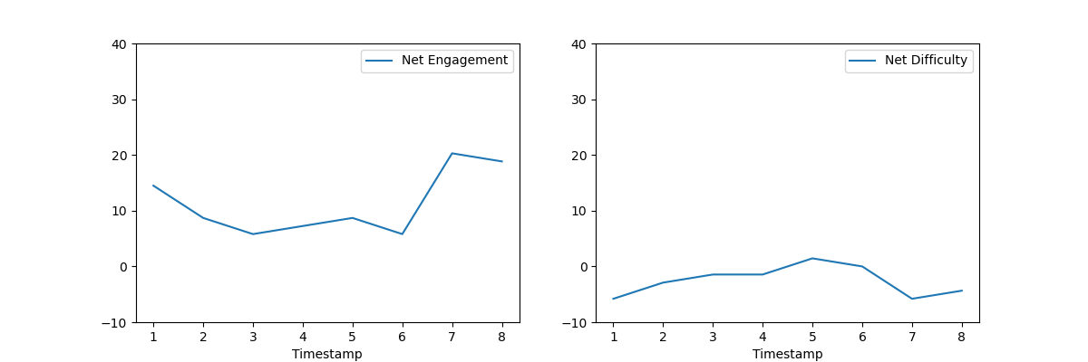

For Dataset 1, we have obtained the following graphs

